**Daily assessment** - 4

**Azure data bricks Assessment** 4

**Date:** 02/01/2024

**Name :** Abhiram Basa

**Topics**: Today we did hands on practice for creating delta tables with existing csv files and project overview

and how to build them and how to make the project documentation

**Data Ingestion:**

In this we can upload data to create the delta tables using local CSV files.

* Create on launch workspace

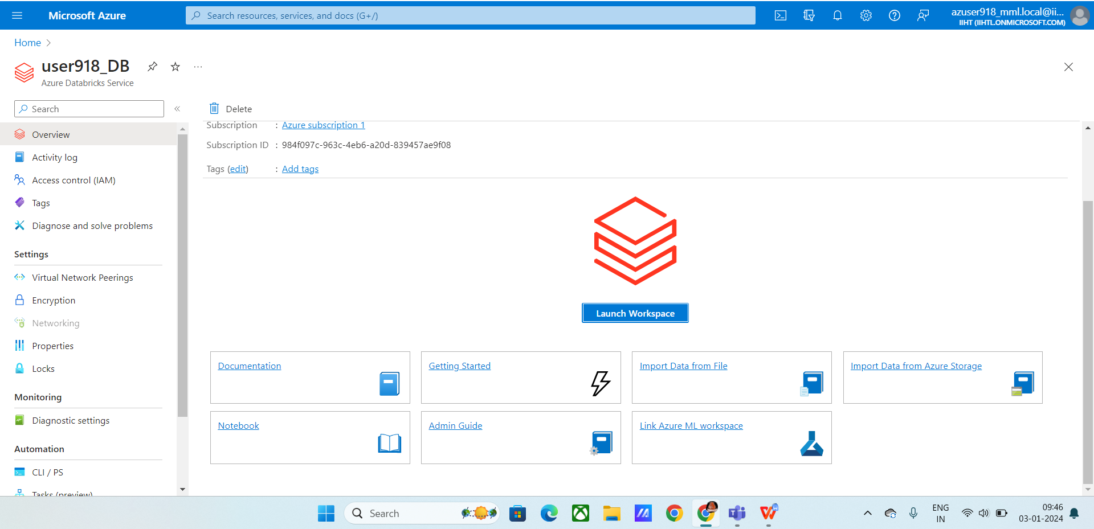

* Click on data ingestion
* Upload the csv file
* It will create table with existing data and columns

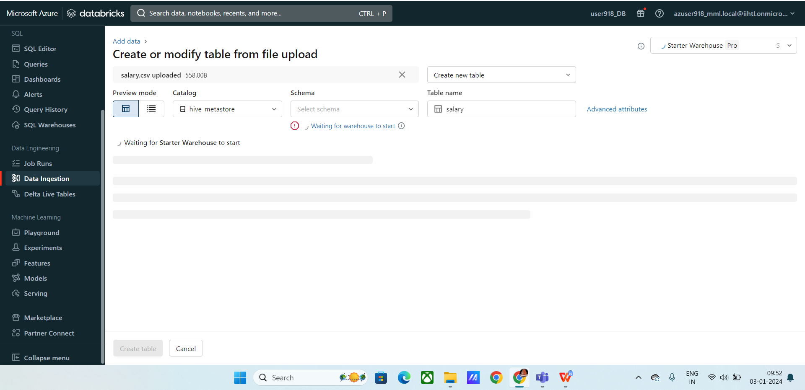

* Created table with existing csv file

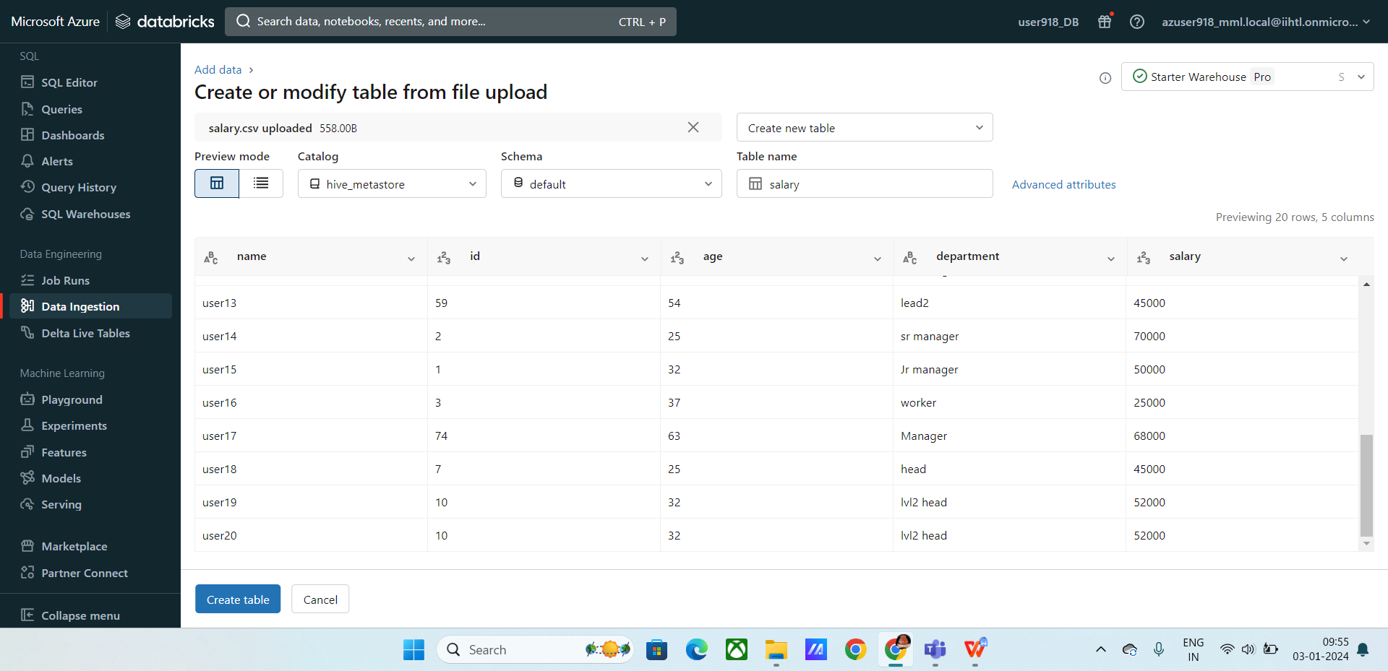

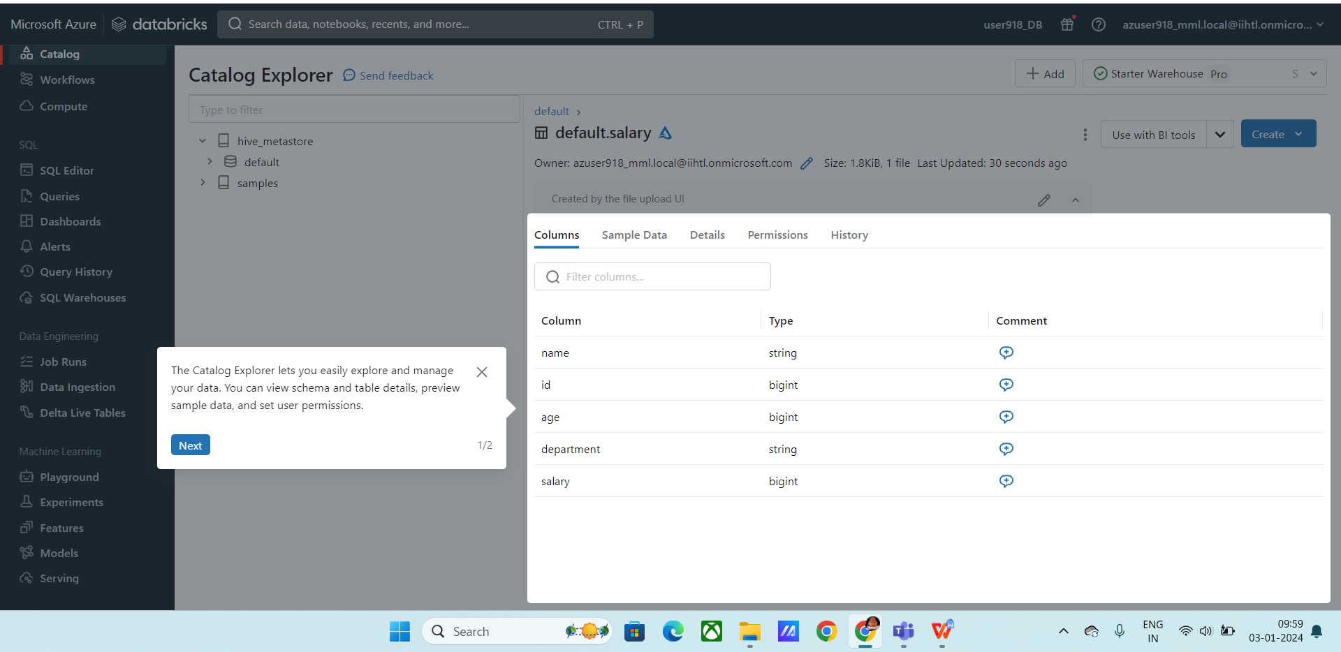

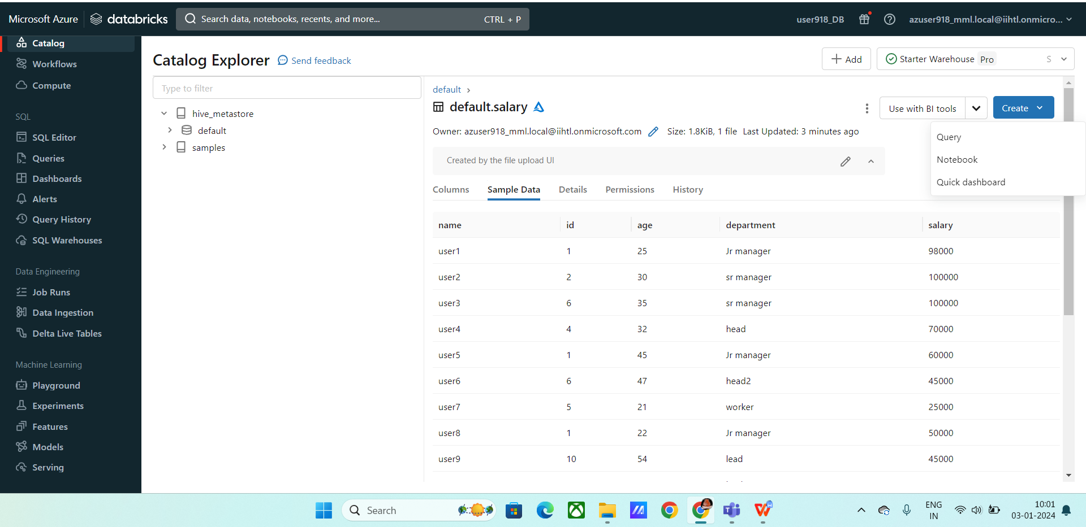

* Click on create and a cluster will be created to execute commands.
* Use %sql to execute sql commands
* Here I have executed sql commands

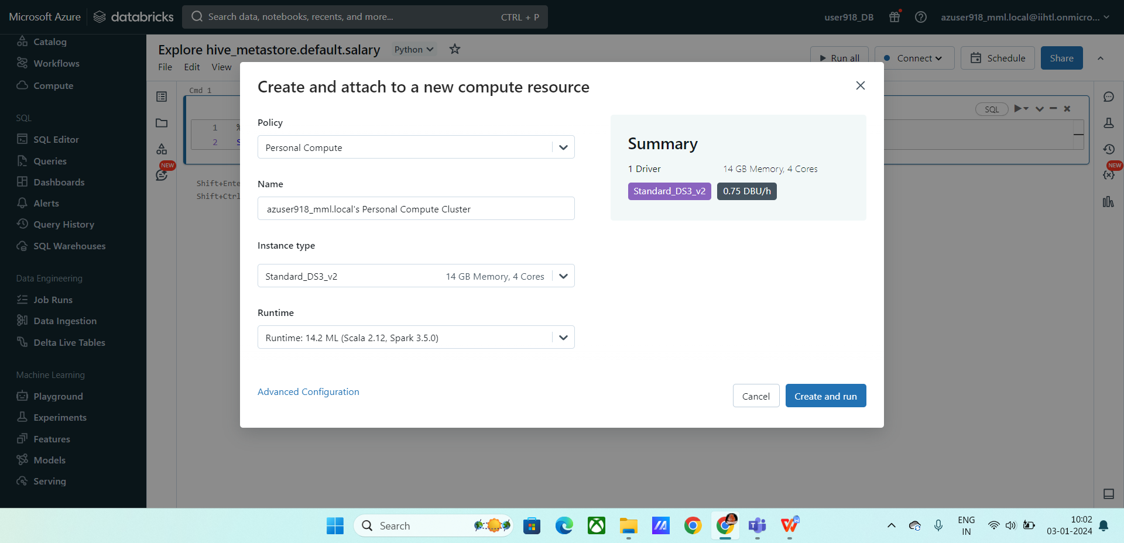

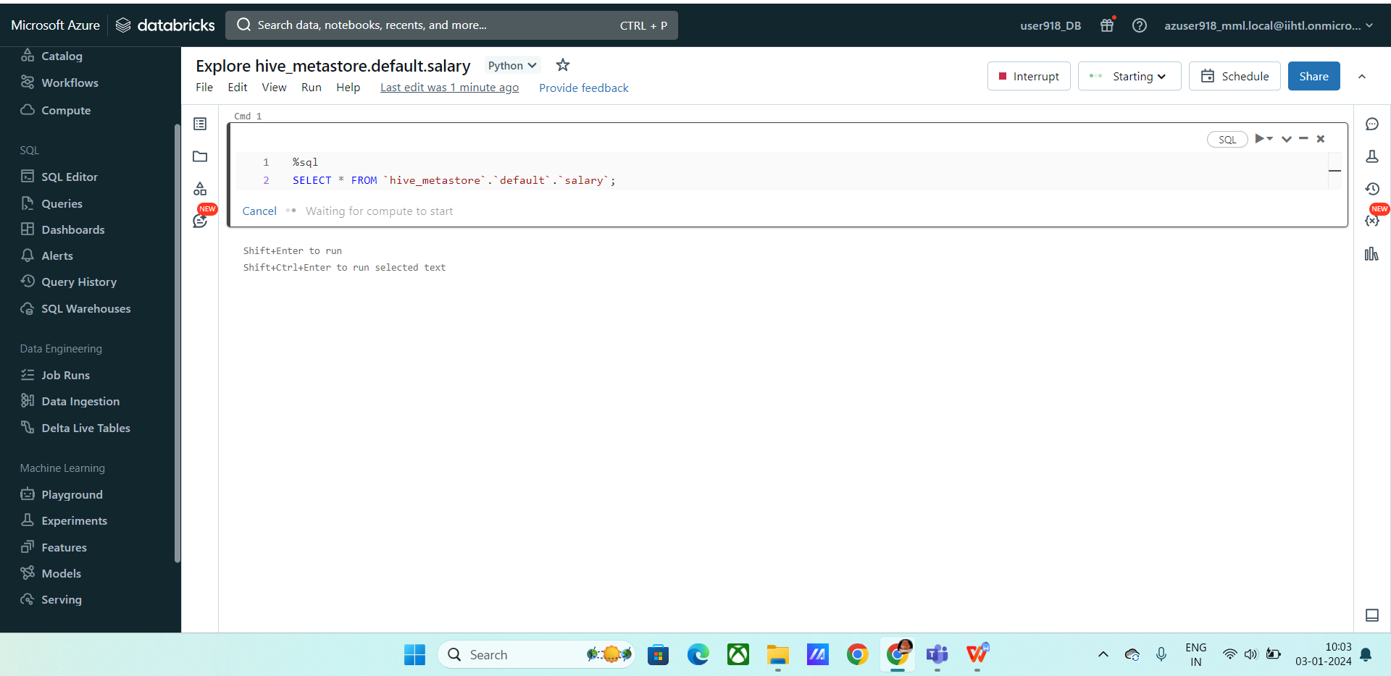

**Delta live tables :** Delta live tables are used to execute commands in the cloud space and used for building pipelines in the future.

One of the very important feature is that we need not to upload files again and again .

The data is stored in delta tables and we can use it for further purposes .

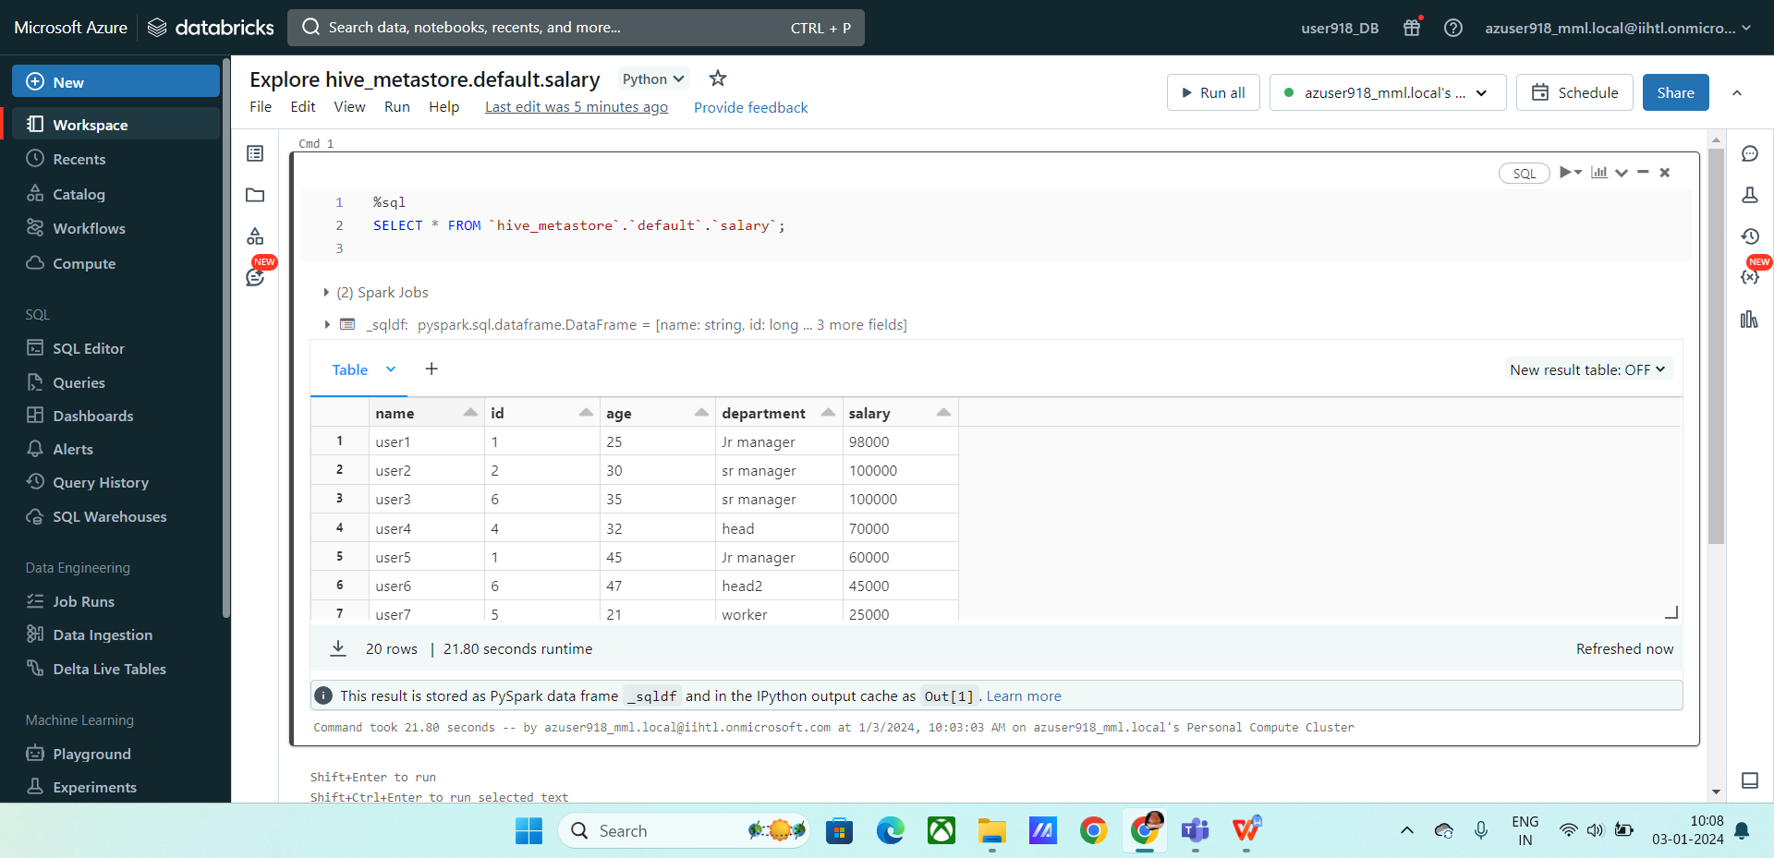

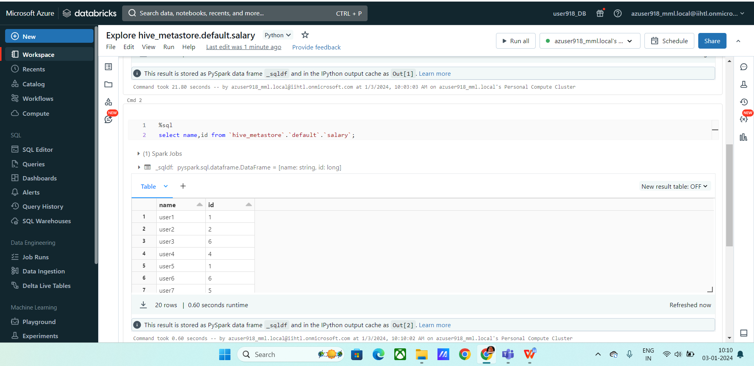

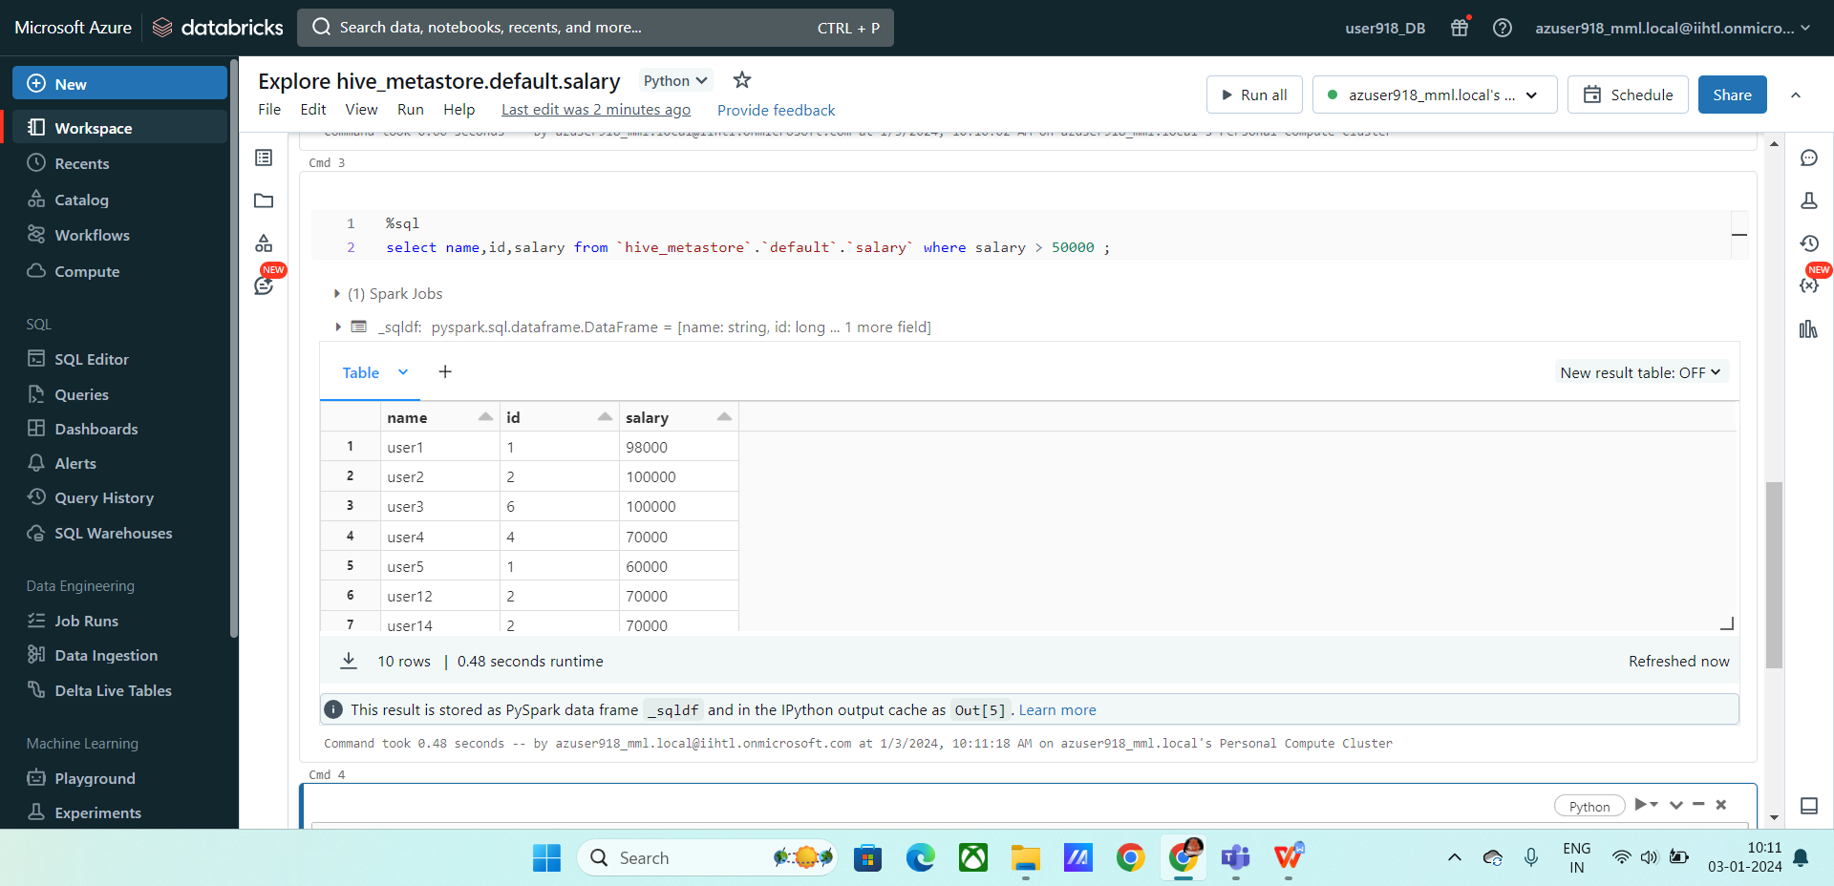

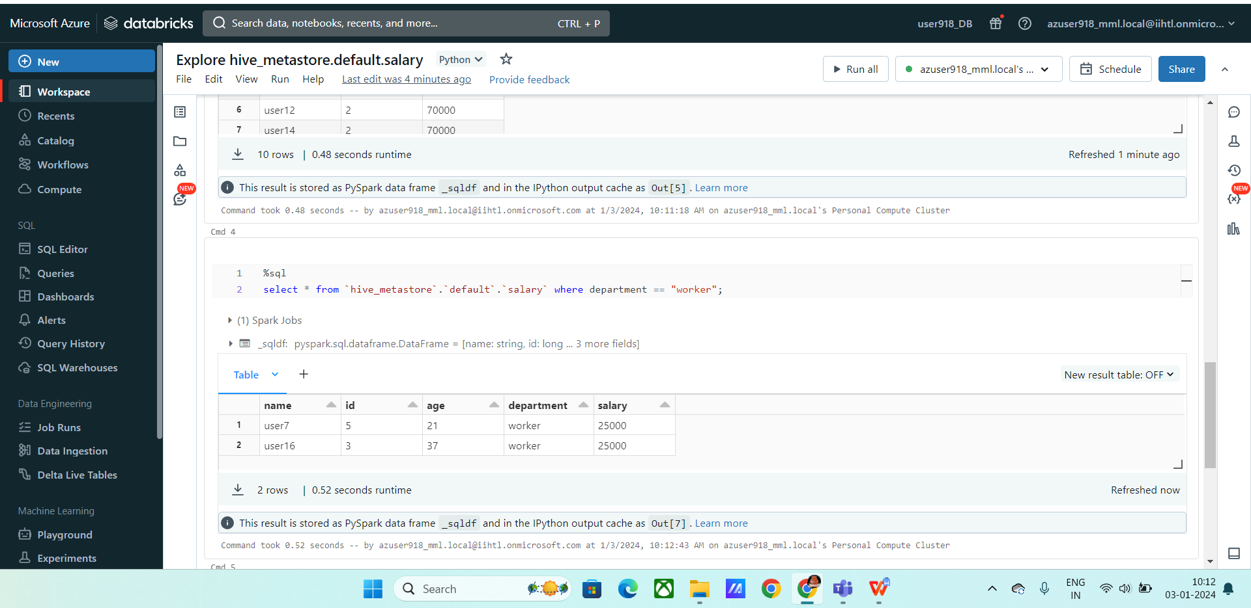

**Project Overview:**

We’ve seen 2 projects and how to build them and how to make the project documentation.

**Documentation**:

**Introduction**: You need to give what is the goal of your project and what you are going to show the output.

**How it works:**

**Data Sources:** You need to specify the data sources where you gathered the sources from.

**Execution Overview:** You need to provide info on how you are going to execute.

**ETL pipeline :**  how you are going to transform data.

**Azure data resources used:** Specify what resources you used to implement this project.

**Project Requirement:**

**Data ingestion**

**Data Transformation**

**Data Reporting**

**Data Analysis**